**CASE STUDY - CONTAINERIZATION USING DOCKER**

**Problem Statement: You work as a Devops Engineer in a leading Software Company.**

**You have been asked to Dockerize the applications on the production server. The company uses custom software, therefore there is no pre-built container which can be used.**

**Assume the following things:**

**1. Assume the software to be installed is apache**

**2. Use an Ubuntu container**

**The company wants the following things:**

**1. Push a container to DockerHub with the above config**

**2. The Developers will not be working with Docker, hence from their side you will just get the code. Write a Dockerfile which could put the code in the custom image that you have built.**

**Commands used:**

**------------------------**

* **sudo apt update**
* **sudo apt install docker.io -y**
* **sudo docker pull ubuntu**
* **sudo docker images**
* **sudo docker run -itd -p 88:80 ubuntu**
* **sudo docker ps**
* **sudo docker exec -it 10b0e0dd7680 bash**
* **history**

**root@10b0e0dd7680:/# history**

* **apt update**
* **apache2 -version**
* **apt install apache2 -y**
* **service apache2 status**
* **service apache2 start**
* **service apache2 status**
* **history**

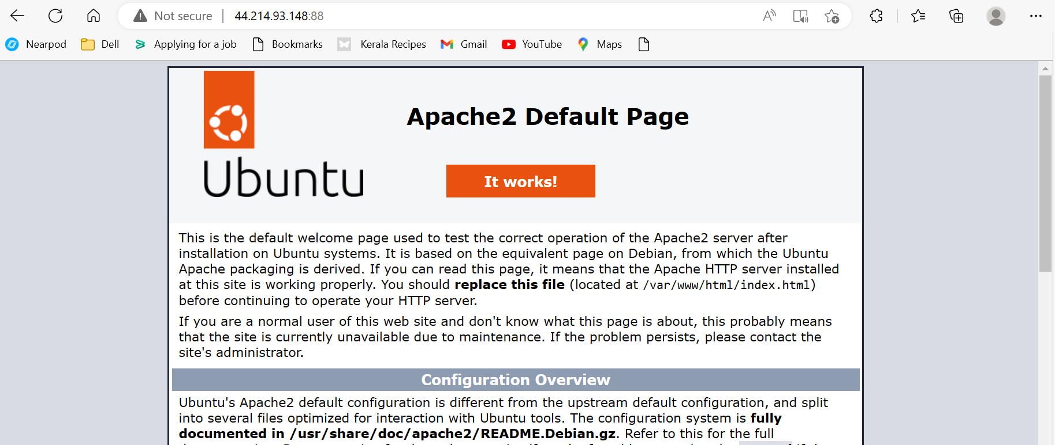

**1. Push a container to DockerHub with the above config**

* **sudo docker images**

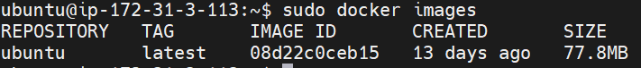

* **sudo docker login**
* **sudo docker tag ubuntu sivakamivinoth/case-study**
* **sudo docker images**
* **sudo docker push sivakamivinoth/case-study**

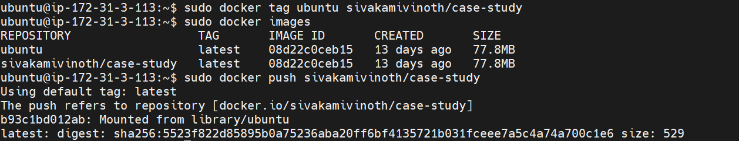

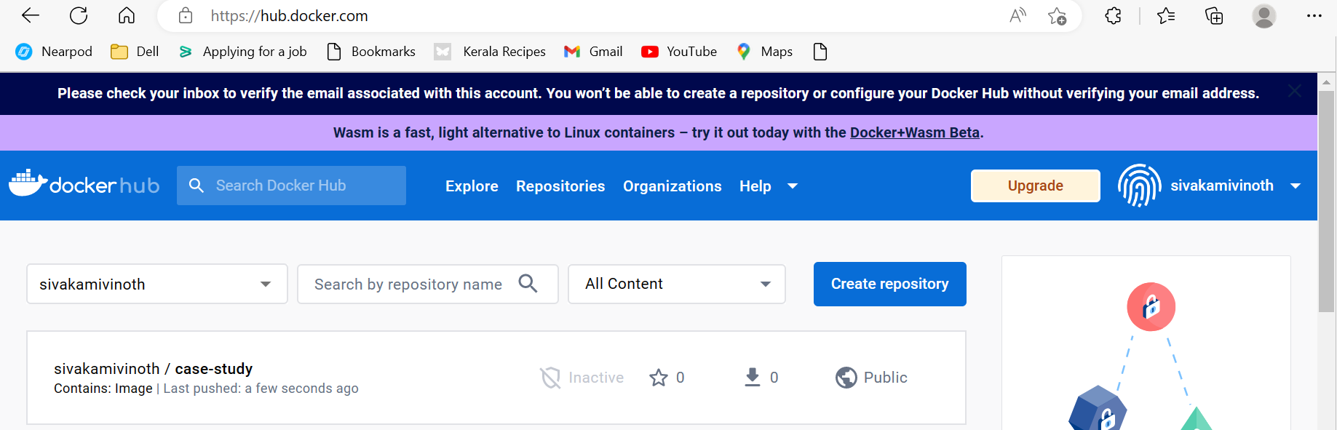

**2. The Developers will not be working with Docker, hence from their side you will just get the code. Write a Dockerfile which could put the code in the custom image that you have built**

* **sudo docker images**

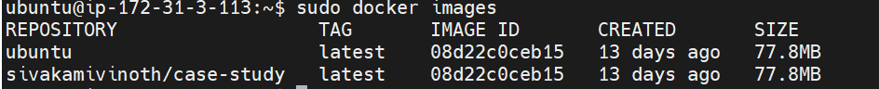

* **sudo nano dockerfile**

FROM ubuntu

RUN apt update

RUN apt install apache2 -y

ENTRYPOINT apachectl -D FOREGROUND

* **sudo docker build . –t case-study**

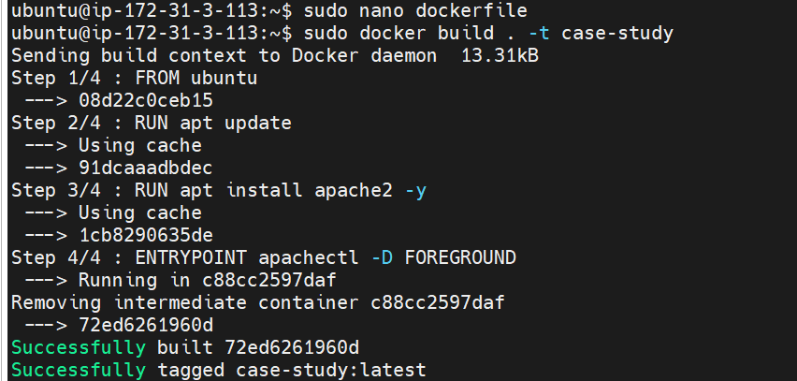

* **sudo docker images**

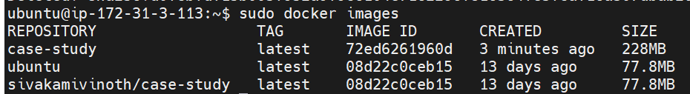

* **sudo docker run -itd -p 90:80 case-study**
* **sudo docker ps**



